Pico Broadcast Platform Development Instructions



Pico Technology Co., Ltd.

2020, May

目录

1. Background 3

2. Introduction 3

3. Manual 3

3.1. Server Manual 3

3.1.1. Objects Descriptions 4

3.1.2. Assets Descriptions 4

3.1.3. Script Descriptions 5

3.1.3.1. CLoadJson.cs 5

3.1.4. Features and Interfaces 5

3.1.4.1. Server.cs 6

3.1.4.2. UIManager： 6

3.1.5. Instructions for Editor debugging in on Server side 11

3.2. Client Instructions 12

3.2.1. Main Scene instructions 13

3.2.1.1. Main 13

3.2.1.2. NetManager 14

3.2.2. NetworkClient.cs： 15

3.2.2.1. Launch.cs 15

3.2.2.2 playController.cs 15

3.2.3. Core scripts： 15

3.2.3.1. Editor debugging of Client 16

# Background

Pico Broadcast Platform is developed by Pico Technology, which aims to provide synchronized multi-user experiences. In this solution, multiple VR standalone headsets will work as clients and PC as server. Server controls all clients all together using the same local network.

To provide better support for partners, now we are releasing Pico Broadcast Platform to open-source platform for our partners.

# Introduction

Pico Broadcast Platform consists of two parts: Server and Client. Open-sourced codes includes both parts. This Instructions are to describe these two parts briefly.

* The Unity Version of the project is **2017.2.2f1**
* You need copy the "pre resource" folder under the broadcast server to the root directory of the device system, if the folder already exists in the directory, merge the folder;
* The APK packaged on the client needs to be signed, and the signing account can be provided by contacting Pico technical support.

# Manual

## Server Manual

Notes: The following parts is brief introductions to server part. For more detailed implementations, please refer to Unity source code.

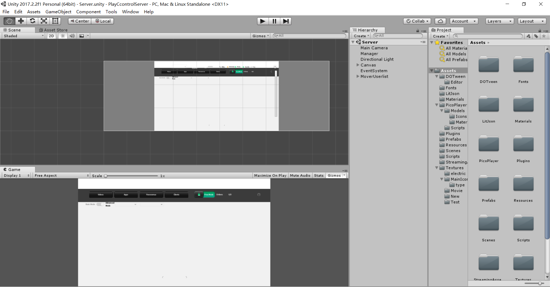

The main Unity scene of Server is as above.

### Objects Descriptions

* **Manager**：Core manager of server which handles: Read broadcast configure files, assets initialization, scripts initialization, server initialization etc.
* **Canvas**，MoverUserlist: UI System, Edits, Display etc.

### Assets Descriptions

Assets category which includes plugins and etc.

* **Scripts**：Source code of scripts
* **Textures**：Texture resources used in Software

Screenshot of main scene’s contents

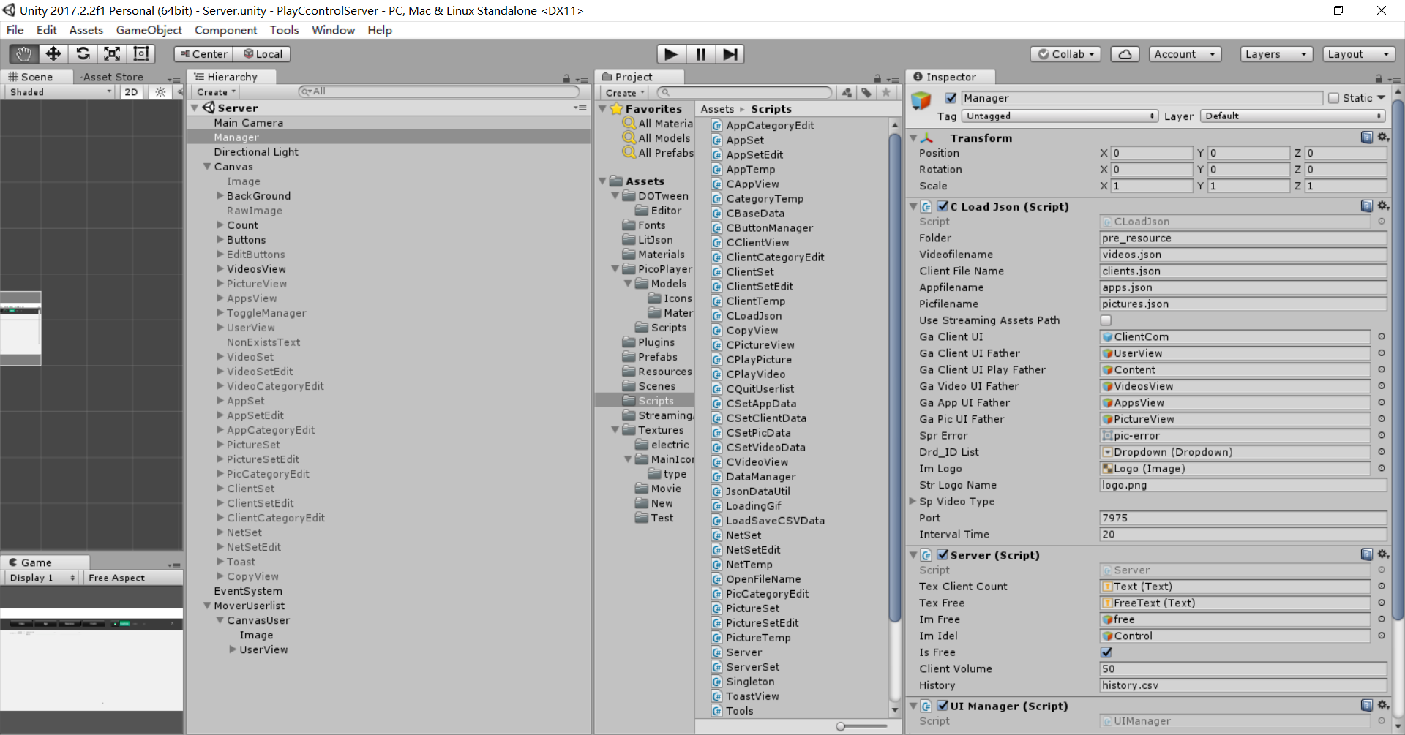

### Script Descriptions

#### CLoadJson.cs

CLoadJson is used to initialize each module. Singleton initialize each module by loading configure files.

### Features and Interfaces

* Start() ： Load configure files , initialize UI, initialize sockets etc.
* void InitSocket() : Initialize Server interfaces
* void SocketSend() : Send sockets
* void SocketReceive() : Receive Sockets
* void SocketQuit() : Close connections
* void fnLoadClientDataOver() : Process client data
* void fnLoadVideoDataOver() : Process video list
* void fnLoadAppDataOver() : Process application list
* void fnDropUserIdSelect : Select User ID to sync
* void fnSetClientStatus : After connection established, use SN code to set client status

Notes: Please refer to source code for details

#### Server.cs

Server is using Unity RPC network transmission, interfaces details:

* public void fnStartServer() Start Server in Simulcast mode
* public void fnStopServer() Stop Server in Simulcast mode
* public void fnStartVideo()Start Video in Simulcast mode
* public void fnPlayVideo(long playTime = 0)
* public void fnPlayPlayingVideo(long playTime = 0) ： Play video in Video Player in Simulcast mode
* public void fnPauseVideo() ： Pause Video in Simulcast mode
* public void fnStopVideo() ： Stop Video or Restart in Simulcast mode
* public void fnPlayPicture(): Play playing picture in Simulcast mode
* public void fnStopPicture() ： Stop playing piucture in Simulcast mode
* public void fnSetClientFreeOrIdle() ： Set Free mode
* public void fnStopOrStartSynchroClient(string strSn, bool IsSynchro)： Synchronize or stop client
* public void fnServerSeekToClient() ： Seek servers to clients

Notes: Find interfaces or usages details in Server.cs

#### UIManager：

UIManager is used for managing UI for each panel

* Switch UI panels and push/pop logic of UI
* GetUI()
* RunUI()
* PushUI()
* PopUI()
* ReplaceUI()

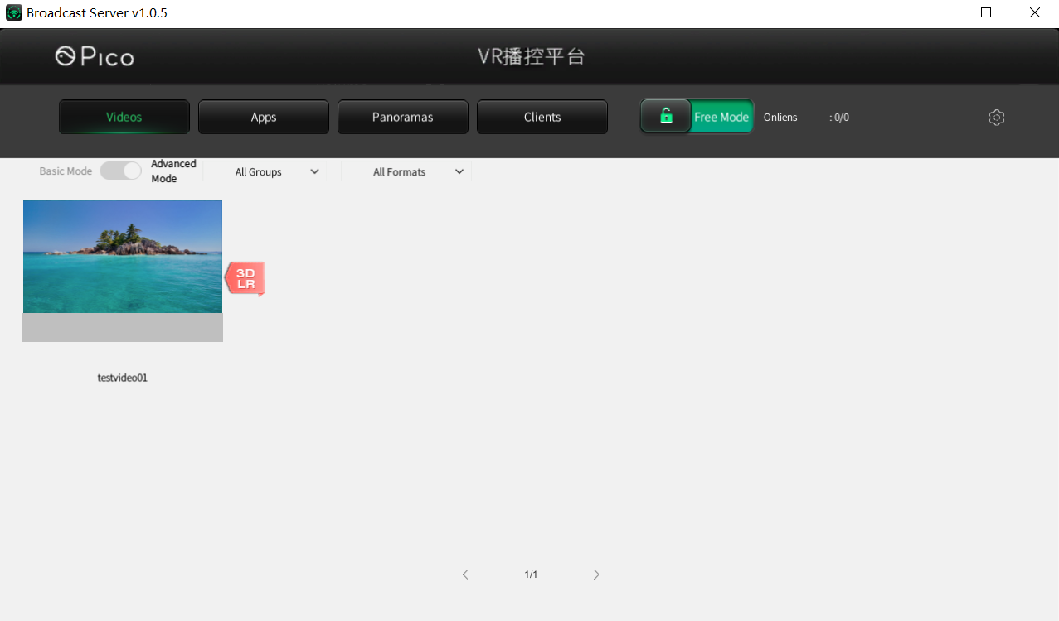

* Video Module：CVideoView.cs

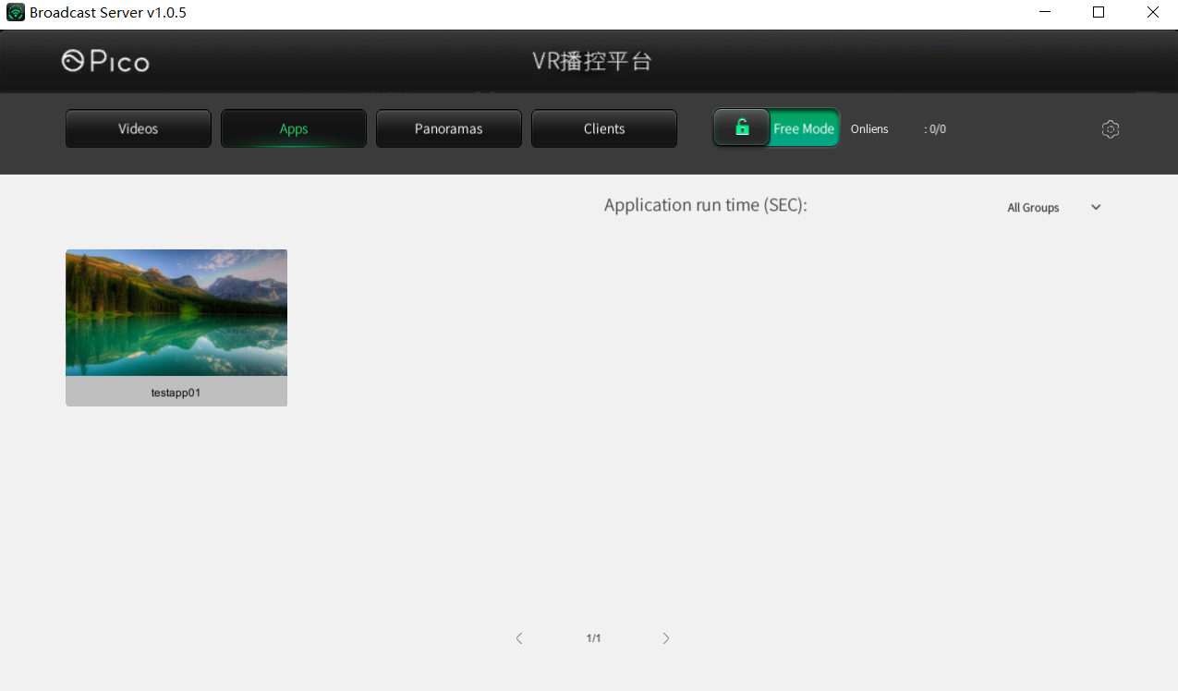

* App Module：CAppView.cs

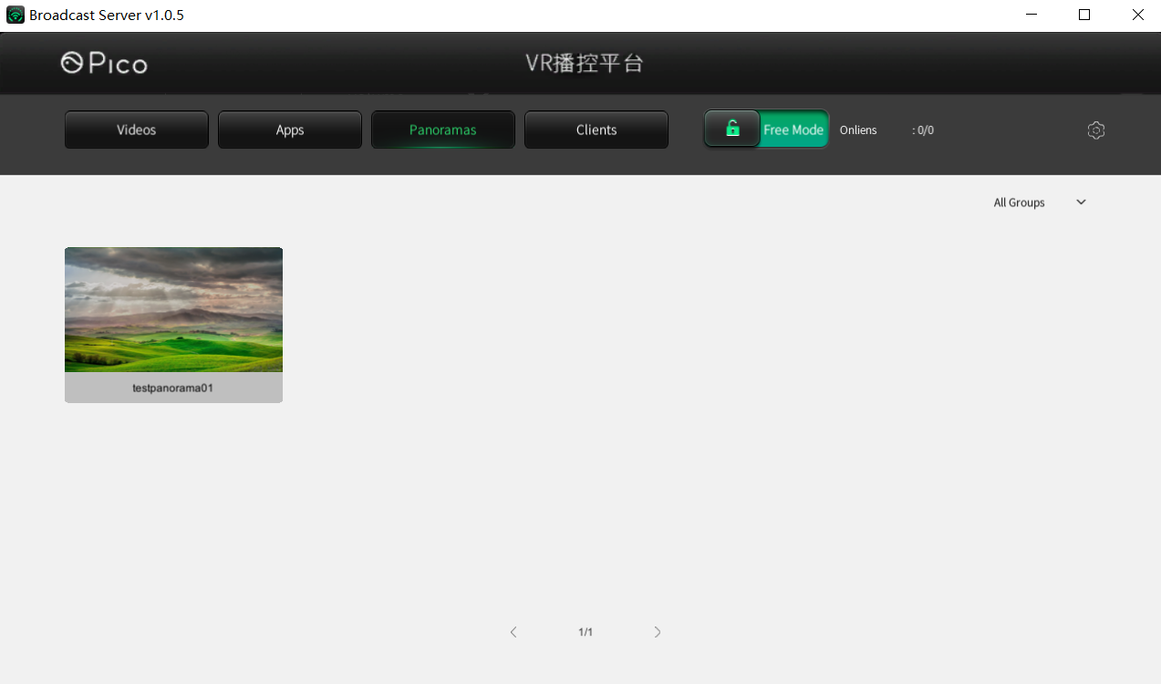

* Panoramic Picture Module：CPictureView.cs

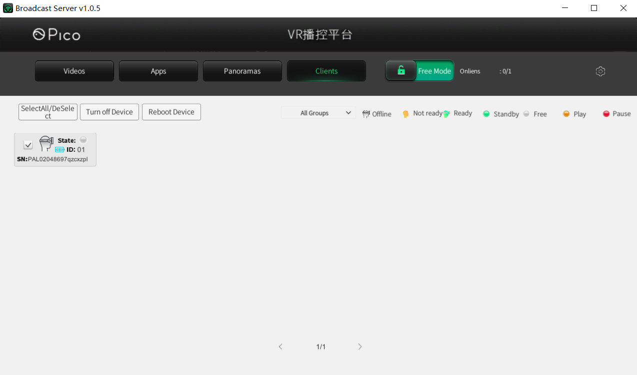

* Client Module：CClientView.cs

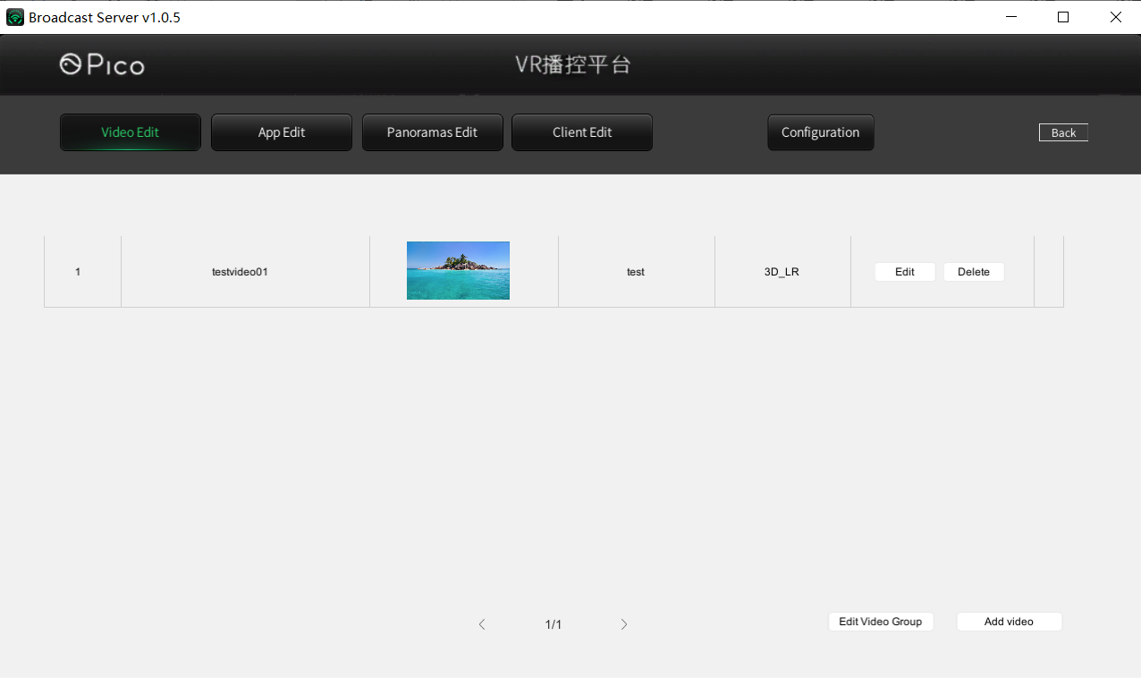

* Video management：VideoSet.cs VideoSetEdit.cs

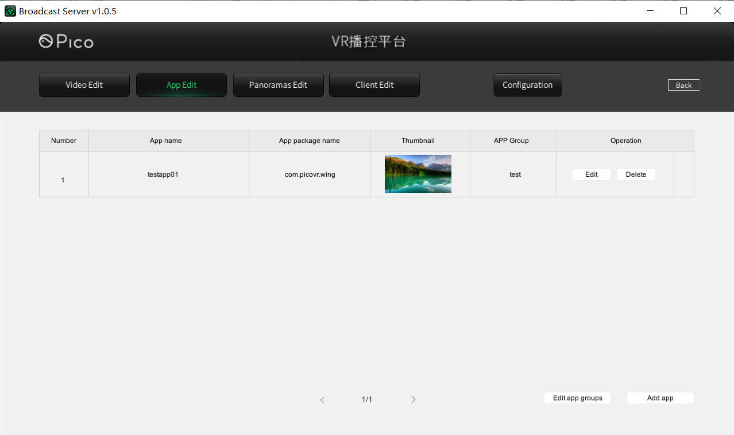

* Application management：AppSet.cs AppSetEdit.cs

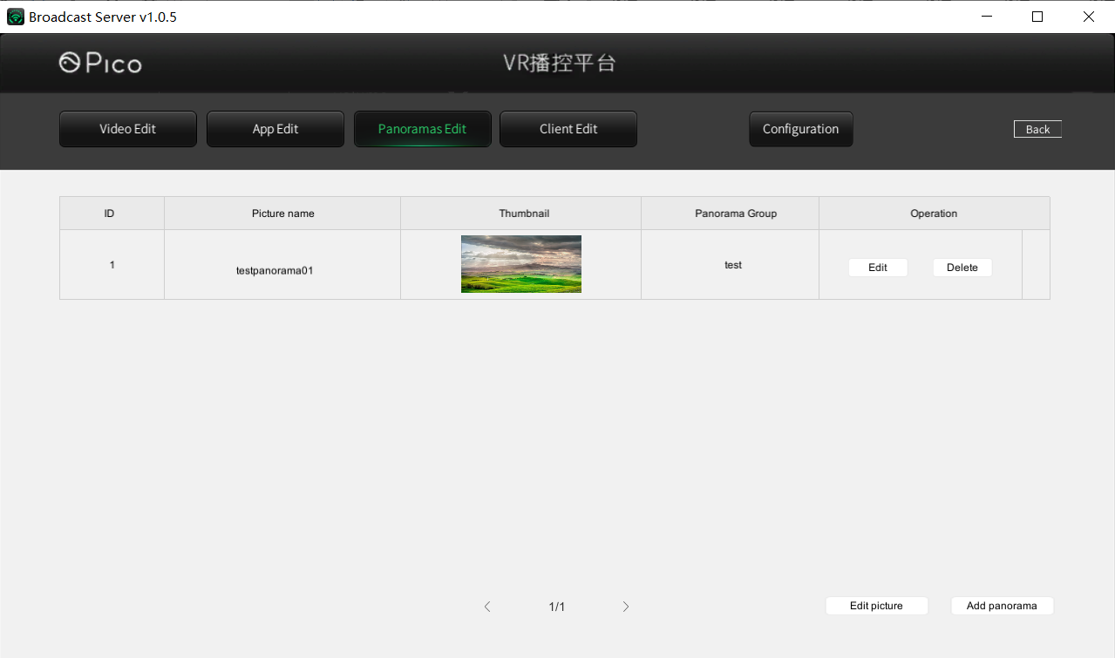

* Panoramic picture management：PictureSet.cs PictureSetEdit.cs

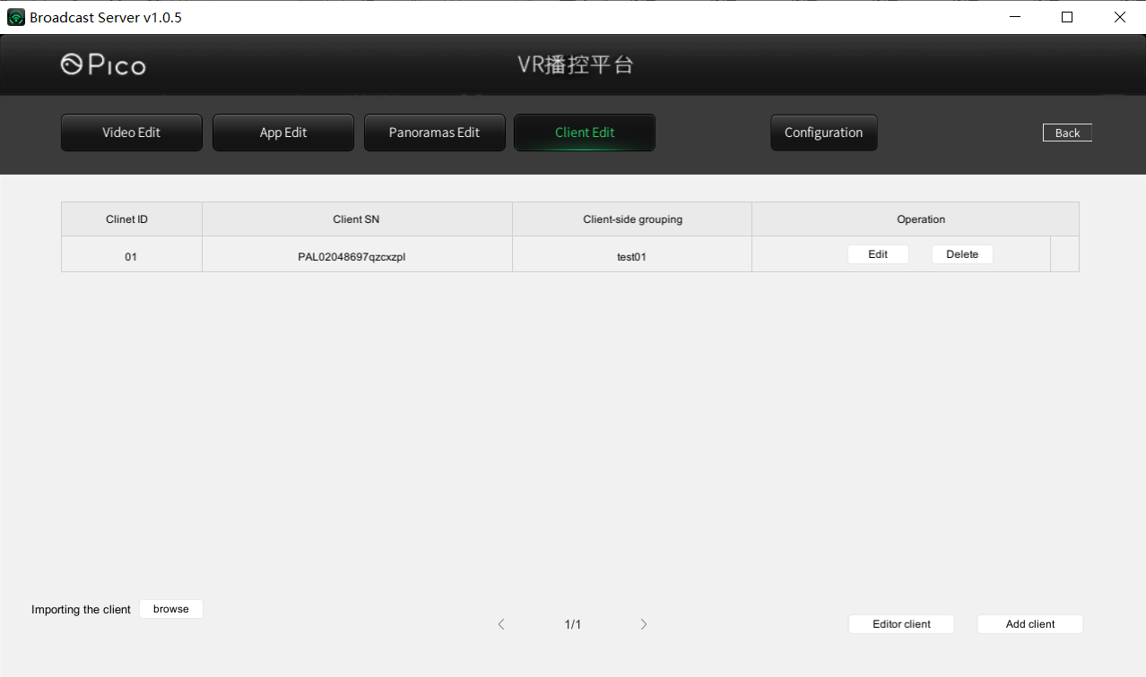

* Client Editting: ClientSet.cs ClientSetEdit.cs

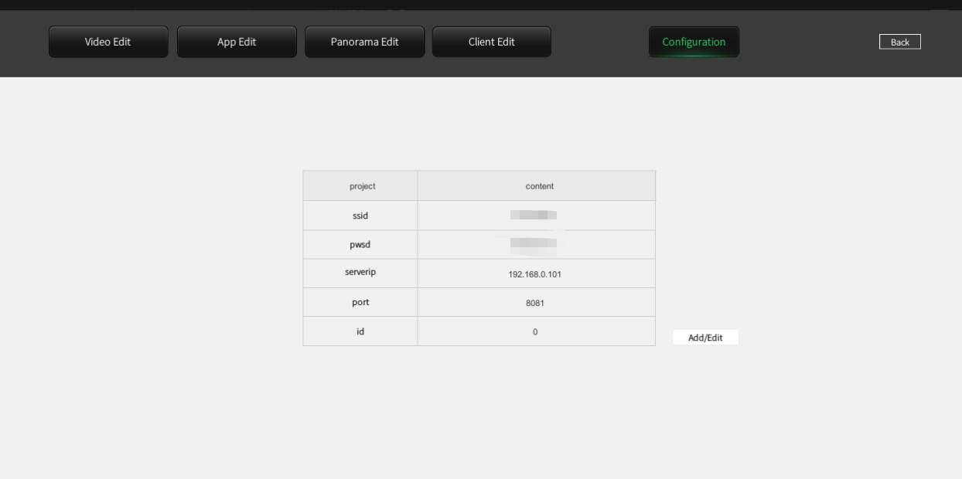

* Network configuration management ： NetSet.cs NetSetEdit.cs
* Note: Add network configuration for connection between client and Server. The specific adding method is as follows:

I. Open the broadcast server folder and start the "broadcast server. exe" program;

II. Click the "Settings" - > "network configuration" icon on the right side of the title bar to enter the "network configuration" interface;

III. click "add / modify"

Enter the relevant information in the input box:

SSID: input the configured Wifi account;

Pswd: enter the configured Wifi password;

ServerIP: connect the PC to the router, check the IP address of the PC, and enter it;

Port and ID are not entered and remain in the default state.

### Instructions for Editor debugging in on Server side

* Place configuration files under path [Server\pre_resource\broadcast] of Server project

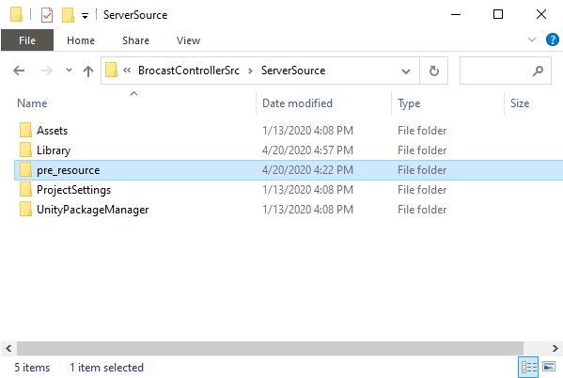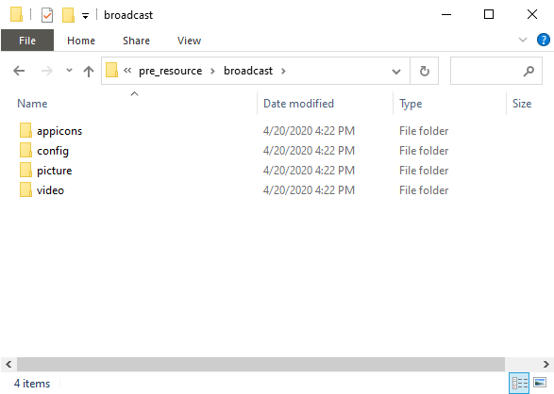

## Client Instructions

* Notes: The following parts is brief introductions to client part. For more detailed implementations, please refer to Unity source code

### Main Scene instructions

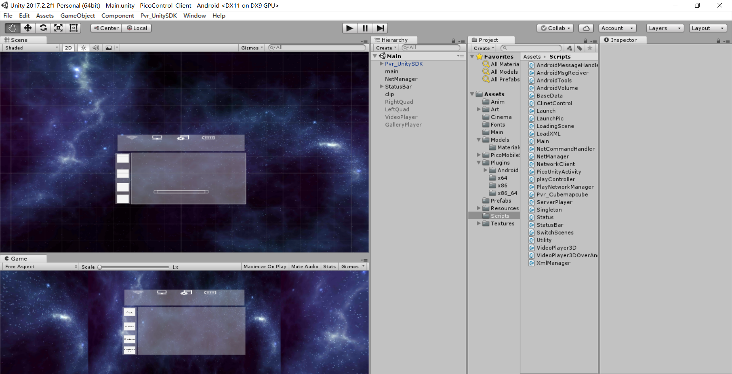

The above screenshot is Main scene of Client

#### Main

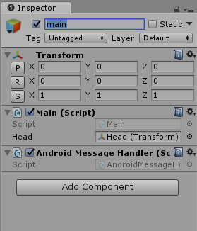

**Main.cs**

Notes： Define singleton, status, initializing UI/assets/scripts

* void Awake() : Gameobject initialization
* Start() : Read configure files, upgrading config from ver 2.0 to 3.0 (leave unprocessed if upgraded), network status monitoring, accept Android data initialization
* private IEnumerator OnClientResume() ： Operate when client returns values and use SendToServerMassage to send messages to server
* private IEnumerator OpenFreeMode() ： Enable Free mode
* private void OnNetStateChanged(bool connected): Operate when network status change
* public void RefreshFiles(string value): Read configure file folder and load each asset

**AndroidMessageHandler.cs:**

Receive android messages and operate，for communications between Unity and Android, please refer to Unity manuals.

* public void Android_SendTimeToUnity(string time) : Time to receive messages from Android side
* public void Android_SendBatteryInfo(string info) ： Receive battery status from Android
* public void Android_SendWifiConnectedToUnity(string connected): Receive Wi-Fi connection infomation
* public void Android_SendWifiStatusToUnity(string state): Receive Wi-Fi status infomation
* public void Android_SendWifiLevelToUnity(string level): Receive Wi-Fi signal level infomation
* public void Android_SendSensorStatusChange(string value): Receive Sensor status infomation

#### NetManager

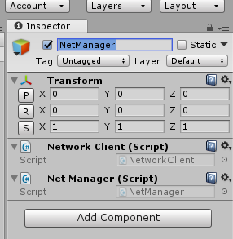

### NetworkClient.cs：

Notes：Client Network operating：

* public void SendToServerMessage(string command, string parameter): Send messages to server
* private void CheckConnection() ： Check connection status
* private void NetStateChanged(bool connected) ： Operation when network status changes
* private void RequestMessage(string command, string parameter, NetworkMessageInfo info): Request data processing
* NetManager.cs: Network managers
* private void OnNetworkCommand(string command, string parameter): Wait to process command messages
* NetCommandHandler.cs: Receive messages from server and process
* public void OnCommand(string command, string parameter) ：command is the command information， parameter is the transmitted String to be parsed（video）
* private bool ParsePlayParameter(string parameter, out int seekPos, out string fullPath, out VideoType mode, out string type): Parse transmitted String（Gallery）
* private bool ParseGalleryParameter(string parameter, out string name, out string category)

#### Launch.cs

Launch.cs: Used to manage the logical relationship between the picture playing module and the video playing module.

* public void StartLaunch(object goal,UIPointerEventArgs currentUI): Select from app mode, video mode and picture mode
* public void Video(string videoname, string videotype):Play video,use videoname and videotype to judge videoname and videotype

#### 3.2.2.2 playController.cs

playController.cs:Used to control the video player.

* public void PlayOrPause():Play video or pause video

### Core scripts：

* BitVideoPlayer.cs : Video player control, please refer comments in scripts
* VideoUIControlBit.cs VideoPlayerUIManagerBit.cs: Display and control UI

#### Editor debugging of Client

* Place configure files in clientCV project under path: (client_cv\unity3d\sdcard\pre_resource\broadcast)；
* Editor support only debugging part of the features, for overall debugging please apply on actual Android device

********************************End************************************